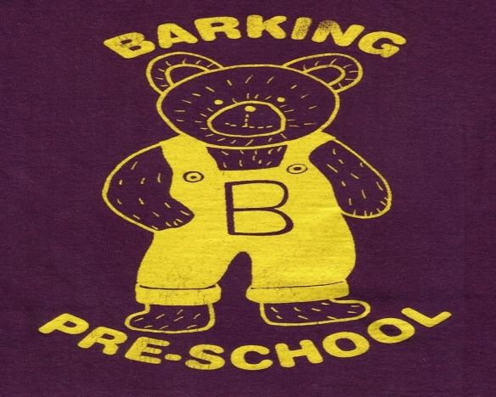
Barking Pre-School Newsletter – January 2017

Dear Parents/Guardians
Happy New Year to you all! We hope you all had a good Christmas! The children have been telling us about some of the lovely gifts Father Christmas delivered so we must have some very good children here at Barking Pre-school!
This term we welcome 4 new children to the setting and we look forward to getting to know them and their families.

Autumn Term Reports
We have now made the Autumn Term reports accessible to parents. A few people have had problems accessing these on the Tapestry app so we would recommend you use the Tapestry website for easier access. Once you have logged in you will see a ‘Children’ tab at the top of the page. Click on this and then click on your child’s name. This will release a drop down menu where you can then select ‘Reports’. Click on the report you would like to read and please remember to add your comments at the end of the report. The ‘Next Steps’ on the report are observations staff need to make during the next term. You may find you have seen your child do these things at home so please feel free to add an observation to support this.

Fundraising Update
Staff, their family and friends managed to fill a coach to Lakeside Shopping Centre back in November. We had a lovely day and managed to raise £195 for the pre-school. Thank you to the 2 parents who donated a raffle prize for this trip.
Our Christmas Raffle and Concert refreshments raised £177; once again, thank you to everyone who supplied raffle prizes and donations on the day! We are sure you will agree the children did us all very proud!

Pre-school clothing
Pre-school Sweatshirts and T-shirts are available to order online at www.pmgschoolwear.co.uk. The company also provides book bags and ruck sacks with the pre-school logo if you are interested. Please ensure all personal belongings and clothing are clearly named to avoid any confusion.
Staff will ensure all children are provided with a pre-school craft bag to take home any creations they make whilst at pre-school. This should be bought to pre-school each time your child attends to prevent wet or sticky paintings etc messing up the children’s own bags with clothing in. If you haven’t already got one, please see a member of staff.

Wellies and Clothing
We try to encourage children to dress themselves when getting ready for the garden so please make sure all items of clothing and personal belongings are clearly named.
With the weather forecast predicting cold wintry weather could we please ask you to ensure your child has a warm coat, hat and gloves and wellies; all clearly named. We aim to take the children out in to the garden most days.

Food Allergies
Could we please remind you we have children in our setting with some food allergies. Please do not bring food or drink (other than water or milk) in to the setting and ensure there are no items of food or medication in your child’s bag which is kept in the cloakroom. Children have access to these bags at all time and are encouraged to get their own items out if required.

Mobile Phones in the main hall
Could we please remind you NOT to use mobile phones in the main hall where the children play. We are required by government legislation to ensure the safety of all children in our care which includes protecting their identity and confidentiality. Unfortunately this includes monitoring the use of photographic devices.

Parent help
We welcome any parents who are able to lend a hand at the end of the session to pack away. Most afternoons the hall is used by other organisations therefore we need to vacate the hall at 1pm. We are always grateful of someone to wash up and tidy the kitchen!

And finally. . . . . .
Please do not hesitate to speak to a member of staff if you have any problems or concerns at any time. We are always available to speak to you!

Term Dates

Spring Term 2017
Friday 6th January 2017 – PD Day
Monday 9th January – Friday 31st March 2016
(Half Term Monday 13th February – Friday 17th February)

Summer Term 2017
Tuesday 18th April – PD Day
Wednesday 19th April – Friday 21st July
Monday 1st May – Closed (Bank Holiday)
(Half Term Monday 29th May – Friday 2nd June)
Autumn Term 2017
Monday 4th September 2017 – PD Day
Tuesday 5th September – PD Day
Wednesday 6th September – Friday 15th December
(Half Term Monday 23rd – Friday 27th October)

