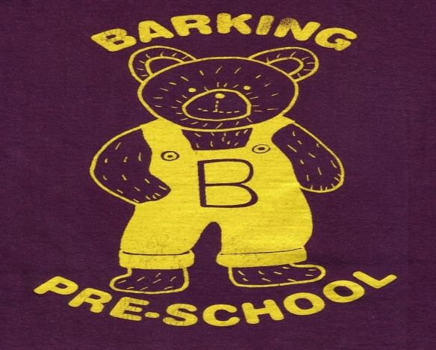
Barking Pre-School Newsletter – June 2017

Dear Parents/Guardians
We are now in the last few weeks of the Summer term and are preparing to say goodbye to 16 of the children in the setting! Staff have tissues ready!
We have invited the Reception class teachers in to meet the children; some of which have already been in to see us. If your child is attending a transition day at their new school, please let a member of staff know when this will be.

Fathers’ Day
We have been handing out invitations for dads, grandads or uncles to ‘Stay and Play’ at pre-school! This has always been a very popular event in the past and the children love to have a male figure in the setting! Please return the slip as soon as possible with the day you would like to attend; you may wish to stay for the whole morning or just a half hour. We realise many of you will have to work and may not be able to take time off so we are happy for any family member to join us.

Tuesday afternoon session
Unfortunately we have had to make the decision to close on a Tuesday afternoon for the Autumn Term 2017. We have only had 6 parents express an interest for their children to attend the whole day which would mean the cost of hall hire and staffing would far outweigh the income. The full day is offered to children who are receiving the 3 & 4 year old funding and with the cut in Government funding we would need a minimum of 12 children attending to break even. We have looked in to offering the full day to our 2 year olds however this would require a higher staff ratio and again the income would not meet our outgoings. We do hope to see an increase after Christmas and are aiming to offer the full day again when this happens.
Staff have been discussing the possibility of offering a lunch club to children and are currently looking in to the hall hire, insurance and Ofsted requirements to see whether this is possible. We will also be handing out a questionnaire for parents to see whether this is something you would be interested in so please return it as soon as possible.

AGM
Thank you to everyone who attended our Annual General Meeting back in May. We thank Dan O’Mahony and Rebecca Palmer for their contribution to the pre-school as they step down and welcome Dan Bradford, Chantal Ellis and Rebecca Newman as new Trustees. Karen Partridge remains our Lead Trustee.
The decision was made to increase the pre-school fee’s for 2yr olds to £15 per session for the Autumn Term which is still less than we receive from the Government for funded 2year olds. This will help with the increase in hall rent we are expecting in September.

Fundraising update
Once again THANK YOU for all your efforts in raising additional funds for the pre-school.
We have received £102.49 so far in the Smartie tubes and still have some to be returned so WELL DONE everyone!
We have also signed up for Easy Fundraising which is a perfect way to raise funds for the pre-school at no extra cost to parents and staff. All you have to do is register at www.easyfundraising.org.uk and select Barking Pre-school as your chosen charity. Each time you shop online, visit this website first and select the shop you want to visit and a donation/commission will automatically be transferred to the pre-school bank account. You can also download an app for your phone! You just need to remember to use the website to be directed to the shop of your choice. It’s so easy and includes holiday companies, ebay, Amazon, supermarkets and many, many more!

Sun Cream and Sun Hats
We are hoping to make use of our outdoor area as much as possible with Summer fast approaching (we hope!). Please ensure you apply sun cream to your child before attending pre-school and provide a clearly named sun hat. We do provide an emergency bottle in the foyer if you forget but staff are unable to apply the product.

Dates for your diary
Saturday 17th June. Somersham school will be holding a Summer Fete 12pm – 3pm. A great opportunity to buy nearly new uniform for children attending the school in addition to a great family afternoon.
Saturday 15th July. Our fundraising committee are organising a children’s disco! Tickets will be on sale soon so please speak to Debbie Shave or a member of staff.
Friday 21st July. We will be organising an end of term picnic for ALL children and their parents so please make a note of the date if you would like to attend.

Pre-school clothing
Pre-school Sweatshirts and T-shirts are available to order online at www.pmgschoolwear.co.uk. The company also provides book bags and ruck sacks with the pre-school logo if you are interested. Please ensure all personal belongings and clothing are clearly named to avoid any confusion.

Parent help
We welcome any parents who are able to lend a hand at the end of the session to pack away. Most afternoons the hall is used by other organisations therefore we need to vacate the hall at 1pm. We are always grateful of someone to wash up and tidy the kitchen!

And finally. . . . . .
Please do not hesitate to speak to a member of staff if you have any problems or concerns at any time. We are always available to speak to you!

Term Dates

Summer Term 2017
Tuesday 18th April – PD Day
Wednesday 19th April – Friday 21st July
Monday 1st May – Closed
Thursday 4th May – Closed (Polling Station)
(Half Term Monday 29th May – Friday 2nd June)
Autumn Term 2017
Monday 4th September 2017 – PD Day
Tuesday 5th September – PD Day
Wednesday 6th September – Friday 15th December
(Half Term Monday 23rd – Friday 27th October)

