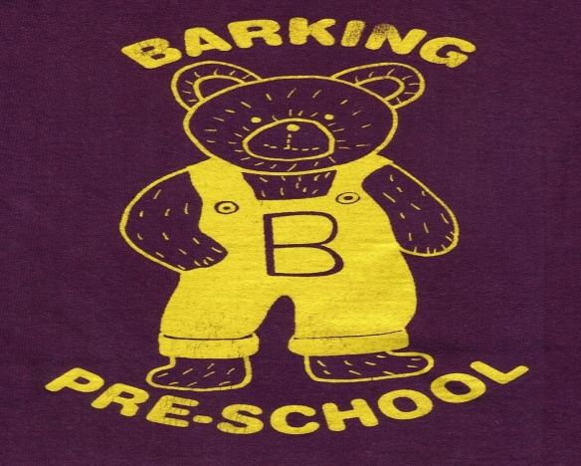
Barking Pre-School Newsletter – March 2017

Dear Parents/Guardians
The end of term is fast approaching but we still have a busy time ahead of us!
By now you should all have received a letter detailing the Suffolk County Council funding cut to all Early Years providers. This is going to make a significant difference to the pre-school income. We now have a committed team of parents raising funds for the pre-school and they have some fantastic events planned for this year. Keep an eye on your newsletter and the posters for full details!

Diaries and Pre-school Bags
Could we please ask you to place your child’s diary in the basket in the foyer on arrival each morning? Staff will collect the basket once all parents have left the building.
We have decided to stop issuing and using the pre-school boxes for children’s paintings etc. Staff will place all art work on a table at the end of the session with your child’s diary for you to collect. We feel the tables used for the boxes will be better used for activities for the children and the boxes are not substantial enough.

Sponsored Listen
Usborne books contacted the pre-school to organise a sponsored listen during World Book week. Sadly only 7 families took part however they did manage to collect £209 in sponsorship! Well done to you all. The children who took part have been given an order form to select their free books and these should be returned to pre-school by Friday 24th March. If anyone else would like to order any additional books, leaflets are in the foyer for you to help yourselves.

Craft and Table Top Sale 2pm – 5pm
Saturday 8th April we will be holding a craft and table top sale to support the pre-school. Please come along and take a look, we have some fab craft stalls and a raffle will be held with prizes including Horse Riding lessons, afternoon tea for two at the Salthouse and many, many more! Tickets are on sale now from Anna (Charlie’s mum) or Debbie (Albie’s mum) for £1 a strip. Refreshments will be available and we are asking for donations of cakes or savouries on the day! Make sure you tell your friends and families so they don’t miss out!

Easter Raffle
A massive thank you to everyone who purchased raffle tickets for the 3 Easter baskets kindly donated by Chantal Ellis. You raised £62 which we will be using for new resources for your children. Prize winners were:
1st – Freddie R
2nd – Albie
3rd - Sonny

Red Nose Day
Friday 24th March is Red Nose Day. We will be providing activities for the children however due to the amount of fundraising for the pre-school, we will not be supporting this charity this year. Children are more than welcome to come to pre-school dressed up but we will not be asking you to make donations.

Pre-school clothing
Pre-school Sweatshirts and T-shirts are available to order online at www.pmgschoolwear.co.uk. The company also provides book bags and ruck sacks with the pre-school logo if you are interested. Please ensure all personal belongings and clothing are clearly named to avoid any confusion.

Food Allergies
Could we please remind you we have children in our setting with some food allergies. Please do not bring food or drink (other than water or milk) in to the setting and ensure there are no items of food or medication in your child’s bag which is kept in the cloakroom. Children have access to these bags at all time and are encouraged to get their own items out if required.

Mobile Phones in the main hall
Could we please remind you NOT to use mobile phones in the main hall where the children play. We are required by government legislation to ensure the safety of all children in our care which includes protecting their identity and confidentiality. Unfortunately this includes monitoring the use of photographic devices.

Parent help
We welcome any parents who are able to lend a hand at the end of the session to pack away. Most afternoons the hall is used by other organisations therefore we need to vacate the hall at 1pm. We are always grateful of someone to wash up and tidy the kitchen!

And finally. . . . . .
Please do not hesitate to speak to a member of staff if you have any problems or concerns at any time. We are always available to speak to you!

Term Dates

Spring Term 2017
Friday 6th January 2017 – PD Day
Monday 9th January – Friday 31st March 2016
(Half Term Monday 13th February – Friday 17th February)

Summer Term 2017
Tuesday 18th April – PD Day
Wednesday 19th April – Friday 21st July
Monday 1st May – Closed
Thursday 4th May – Closed (Polling Station)
(Half Term Monday 29th May – Friday 2nd June)
Autumn Term 2017
Monday 4th September 2017 – PD Day
Tuesday 5th September – PD Day
Wednesday 6th September – Friday 15th December
(Half Term Monday 23rd – Friday 27th October)

