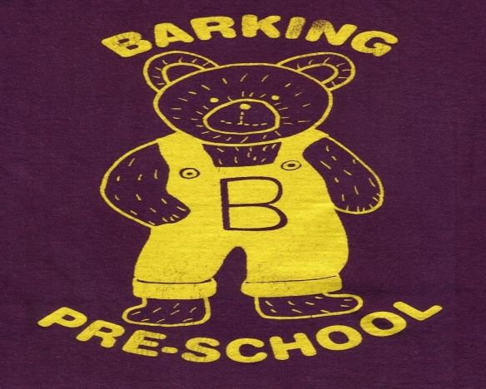
Barking Pre-School Newsletter – October 2017

Dear Parents/Guardians
We start this half term with some excellent fundraising news! We were delighted with the attendance and support of our 30 year anniversary celebrations on Saturday 14th October. The hall was busy all day and we managed to raise a staggering £992.57! Two parents have taken part in sponsored events for the pre-school raising over £500 between them and we have also had a very generous donation from a local accountancy firm; John Phillips & Co of £250.
Our thanks must also go to our fundraising committee who helped organise a Halloween party at the Limeburners in Offton on Saturday 28th October. We have had some lovely feedback from parents who attended the event and were delighted to receive a £207 contribution from the landlady! On behalf of all the staff A VERY BIG THANK YOU TO EVERYONE for your fundraising efforts this past half term!

Extra session
We have been asking parents for their childcare requirements after Christmas and now have enough children to re-introduce our full day on a Tuesday. This facility is offered to our older children to keep the staff/child ratio low.
The session is structured for more adult led activities and will prepare children for the transition to primary school. Children will need to bring a packed lunch please. We currently have children with food allergies therefore please ensure food does not contain nuts.
For those of you who haven’t already done so, could you please speak to a member of staff if you would like any extra sessions in the Spring Term (Jan – March).

Wellies and coats!
With the weather becoming much colder now we would like to remind you to provide wellie boots and coats for your children. We aim to take the children outside most mornings and would ask all personal items are clearly named to allow us to encourage independent dressing and undressing when getting ready for outside play.

Lunch Club
We are now started offering a lunch for a 7 week trial period. The cost of the lunch club is £2.50 per day finishing at 1.15pm. Children will need to bring a packed lunch and parents will be invoiced for the half term period. We aim to be flexible with this facility therefore if you have not booked a space during the lead up to Christmas and feel you would benefit from the additional 45 minutes childcare at short notice you can pay on the day.

Safeguarding Update
After attending a recent Safeguarding training update we have been advised to revise our social media policy. We are currently in the process of reviewing all policies however staff have been instructed to remove ALL parents of children currently at our setting with immediate effect from all social media websites; Facebook, twitter, Instagram etc. We realise this may seem quite hostile however please remember staff can be contacted on the pre-school landline or mobile telephone during session times or by email info.barkingpreschool@aol.com and Tapestry out of hours and holidays. The email account will be checked regularly out of hours for any emergencies or enquiries.
Our fundraising committee have created a Facebook page to advertise the events planned however we must ask that pre-school business is NOT posted on this page. We will be removing any comments unrelated to the events as soon as we see them. Any pre-school enquiries should be addressed directly to staff or the pre-school email.

Children in Need
We will once again be supporting this charity and invite children to attend pre-school during the week commencing Monday 13th November in their pyjamas/onesies for a minimum donation of £1. We will be running activities throughout the week and staff will be joining in with the dressing up on Friday 17th November.

Poppy Appeal
You will see we have been asked to collect on behalf of the British Legion. If you would like your child to have a poppy please send in your donation in a named envelope or place your donation in the tin when you visit the setting.

Dates for your diary

Saturday 25th November. Our fundraising committee are organising a Christmas Fayre with craft and trade stalls for you to start your Christmas shopping. Further details will be given after half term but please save the date!
Sunday 26th November. We are organising a coach trip to Lakeside Shopping Centre leaving Needham Market at 9am and returning for home at 5pm. Seats are £14.50 each and we will have a raffle on the coach to raise money for the pre-school. Please speak to a member of staff if you would like to reserve a seat.

Parent help
It has never been so vital for us to welcome any parents who are able to lend a hand at the end of the session to pack away. We are always grateful of someone to wash up and tidy the kitchen!

And finally. . . . . .
Please do not hesitate to speak to a member of staff if you have any problems or concerns at any time. We are always available to speak to you!

Term Dates
Autumn Term 2017
Monday 4th September 2017 – PD Day
Tuesday 5th September – PD Day
Wednesday 6th September – Friday 15th December
(Half Term Monday 23rd – Friday 27th October)

