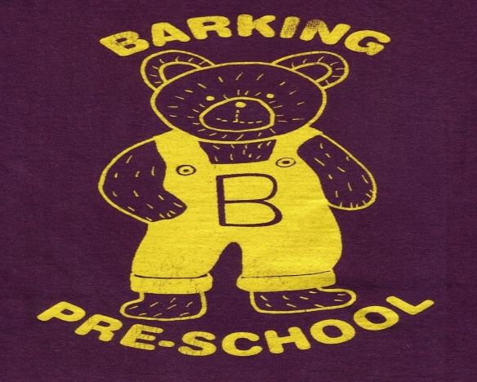
Barking Pre-School Newsletter – September 2017

Dear Parents/Guardians
Welcome back to the start of another academic year! We hope you all had a lovely Summer break; it seemed to go so quickly! We welcome 3 new families to our setting and look forward to getting to know Sam, Elsie and Lilah. We are really pleased to have Lucian rejoin us too!

Your child’s Key Person
We have had to make some changes to the allocation of children to a key person because of the reduction in staff working hours. To limit the number of changes made we are introducing a ‘buddy system’ to allow staff to work in pairs ensuring observations and assessments are made on a regular basis on all children. Details of your child’s keyperson are listed on the parent information board in the foyer.

Contact details
Could we please ask you to ensure we have the correct contact details for you and your chosen people with authorised collection in an emergency? Speak to a member of staff if you think your information may be out of date and we will check your forms while you are with us.

Wellies and coats!
The Summer weather seems to have disappeared very quickly so we would like to remind you to provide wellie boots and coats for your children; clearly named to allow us to encourage independent dressing and undressing when getting ready for outside play.

Pre-school Finances
You will all be receiving a letter detailing the current financial situation of the pre-school. The high profile in the news of the Early Years funding cuts may have caused concern for some parents and we have tried to be open and honest about our finances to highlight the problems this is causing but also to reassure you we are doing all we can to overcome these problems.

Lunch Club
Before the Summer break we discussed the possibility of offering a lunch club for children at an additional cost. Although the initial interest was low we have now had a few more enquiries. The cost of the lunch club would be £2.50 per day finishing at 1.15pm. We are currently discussing the availability of the hall with the management committee and are hoping to offer this facility in the very near future. If you would like to make use of this facility please speak to a member of staff to enable us to finalise numbers.

Fundraising update
Once again THANK YOU for all your efforts in raising additional funds for the pre-school.
We have signed up for Easy Fundraising which is a perfect way to raise funds for the pre-school at no extra cost to parents and staff. All you have to do is register at www.easyfundraising.org.uk and select Barking Pre-school as your chosen charity. Each time you shop online, visit this website first and select the shop you want to visit and a donation/commission will automatically be transferred to the pre-school bank account. You can also download an app for your phone! You just need to remember to use the website to be directed to the shop of your choice. It’s so easy and includes holiday companies, ebay, Amazon, supermarkets and many, many more!

Dates for your diary
Saturday 14th October – 30 Year Anniversary
Barking Pre-school has been established for 30 years this year! To celebrate this wonderful achievement we are organising an Open Day with BBQ (under a marquee!) activities and games for adults and children, raffle and of course CAKE! We are hoping to attract everyone who has had any involvement with the pre-school during the past 30 years to raise much needed funds for pre-school so please spread the word! 10am – 4pm.

Saturday 25th November. Our fundraising committee are organising a Christmas Fayre with craft and trade stalls for you to start your Christmas shopping. Further details will be given after half term but please save the date!
Sunday 26th November. We are organising a coach trip to Lakeside Shopping Centre leaving Needham Market at 9am and returning for home at 5pm. Seats are £14.50 each and we will have a raffle on the coach to raise money for the pre-school. Please speak to a member of staff if you would like to reserve a seat.

Pre-school clothing
Pre-school Sweatshirts and T-shirts are available to order online at www.pmgschoolwear.co.uk. The company also provides book bags and ruck sacks with the pre-school logo if you are interested. Please ensure all personal belongings and clothing are clearly named to avoid any confusion.

Parent help
It has never been so vital for us to welcome any parents who are able to lend a hand at the end of the session to pack away. We are always grateful of someone to wash up and tidy the kitchen!

And finally. . . . . .
Please do not hesitate to speak to a member of staff if you have any problems or concerns at any time. We are always available to speak to you!

Term Dates
Autumn Term 2017
Monday 4th September 2017 – PD Day
Tuesday 5th September – PD Day
Wednesday 6th September – Friday 15th December
(Half Term Monday 23rd – Friday 27th October)

